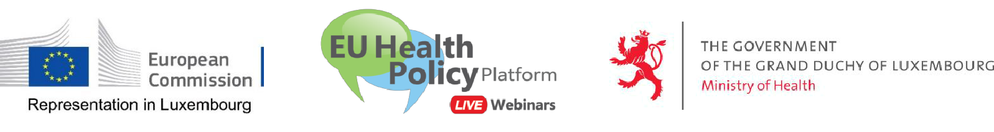

Invitation to our first webinar!

COVID-19
European Coordinated Response to the pandemic

Thursday 16 April 2020 – 10.00 to 11.30

Due to the current circumstances, we are unfortunately not in the position to offer you the usual choice of regular conferences at the Maison de l’Union européenne. So we have to innovate, and would like to propose a new form of meeting: the webinar, an online and live meeting.

The Representation of the European Commission in Luxembourg, in cooperation with the EU Health Policy Platform of the European Commission, is very pleased to invite you to participate in this first webinar conference about the efforts undertaken at the European and national level to deal with the COVID-19 pandemic and to answer your questions.

We propose the following agenda:

10.00 – 10.15 Introduction and welcome

 | Ms Yuriko Backes, Representative of the European Commission in Luxembourg
 | John F. Ryan, Director, DG for Health and Food Safety of the European Commission
10.15 – 10.30 | COVID-19 pandemic: epidemiological situation and risk assessment
 | Ms Anastasia Pharris, European Centre for Disease Prevention and Control (ECDC)
10:30 – 10.45 How the Commission supports Member States
 | Ms Ingrid Keller, Policy Officer, DG for Health and Food Safety of the European Commission
10.45 – 11.00 | COVID-19 pandemic measures taken in Luxembourg
 | Mr. Jean-Claude Schmit, Director, Health Directorate, Ministry of Health - Luxembourg
11.00 – 11.25 | Discussion with the audience
11.25 – 11.30 | Conclusions
 | Ms Yuriko Backes, Representative of the European Commission in Luxembourg

The webinar will be held in English but questions can be asked in French and German. You will find hereafter all the practical information you need to join and participate. No registration is required.

Please join us. We are looking forward to welcoming you online!

Yuriko Backes
Representative of the
European Commission in Luxembourg

Practical information to participate in this webinar

(1) Add the webinar to your calendar – no registration required

https://ecwacs.webex.com/ecwacs/j.php?MTID=ma677210eaab2619a09c840dec2c3cbb3

- To join the Webinar, click on the link below: Thursday 16 April at 10.00 CET, Brussels time
https://ecwacs.webex.com/ecwacs/j.php?MTID=ma677210eaab2619a09c840dec2c3cbb3

On the day of the webinar follow above link and enter:

- your name, surname and organisation: this is mandatory in order to participate.

- your email address

- meeting ID (access code) (if requested): 844 008 124

- password (if requested): webinar2020 (93246272 from phones)

The moderator reserves the right to expel any participant considered as spam.

Microphones will be muted by default. Do not unmute your microphone during the presentations.
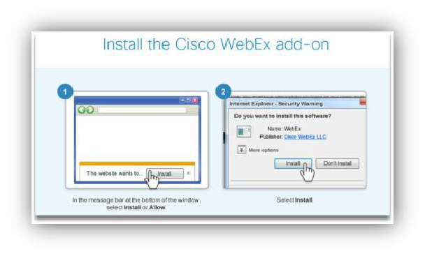

Note: If you have never used this application before, you might be asked to install the Cisco WebEx add-on. Just follow the steps as indicated on your screen.

(3) Audio connection:

To connect to the audio of the webinar, you can choose among three options that will appear on your screen:
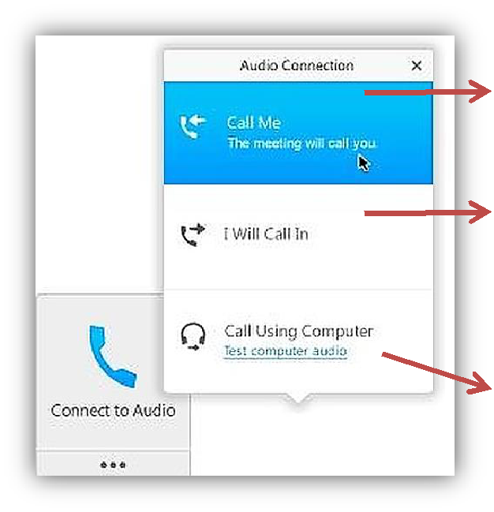

Call me: please click, enter your phone number and country as requested. The meeting will call you.

I will call in: you will call
- +32 (0)22008147 from Belgium

+352 24871056 from Luxembourg More country numbers
- And type your meeting ID (access code): 844 008 124

Call using computer: you will need a headset.

(4) Video connection:

You can also dial in using your videoconference system: 844008124@ecwacs.webex.com

Can't join the meeting?

- Watch the tutorial How to join a WebEx meeting in French or in English

- Read the users' guide Getting started Joining a WebEx Meeting.

- Contact us: sante-hpp@ec.europa.eu

Disclaimer: Note on processing of personal data in the context of the webinar:

By registering and logging on to this Webinar, the participant agrees to the following:

- personally identifiable information of participants may be heard, seen, read, collected, or used by DG Directorate-General of Health and Food Safety of the European Commission as the organizer and by the other Webinar participants;

- any communication or information transmitted during the Webinar, such as voice, instant messages,

or presentations are available to and may be recorded and further used by DG Directorate-General of Health and Food Safety of the European Commission as the organiser;

- DG Directorate-General of Health and Food Safety of the European Commission
may further use the information available on the Webinar
- organization such as the invitee lists, the attendee logs and the Webinar subject matter information.

This Webinar participants shall apply appropriate circumspection when

directly disclosing their personally identifiable information or personally sensitive data on the occasion of the Webinar, since this information may be collected and used by other participants.

